**Bootstrap:**

Developed by Twitter. Second most starred repository on GitHub. Front end library.

**Topics covered in the video:**

1. **What is bootstrap?**   
   It is a CSS frontend library with predesigned CSS styles of a lot of things, based on the classes premade in bootstrap, we can just include the class and obtain a basic level of designing on our own. We can customise as per our requirements to a certain extent.
2. **Wireframing?**  
   Making a rough sketch or prototype which clearly describes the layout of content on the website. There are websites like Figma, moqups etc to do this.   
   It is related to the web-designing part. We will talk about this later.
3. **Bootstrap contents for the current project**
   1. **Installation**CDN – Content Delivery Network. [Bootstrap link](https://cdn.jsdelivr.net/npm/bootstrap@5.2.3/dist/css/bootstrap.min.css) We add this script link in our HTML header to include bootstrap. Or you can download the library and include the local files through a relative path.
   2. **Bootstrap Navigation Bar**The navbar is a class in bootstrap, used to design the first horizontal navigation bar in any website which is seen at the top of each website. We can make it responsive based on – pc, tab, mobile viewport. The functionality it provides would be drop down in smaller screen sizes, positions, margin between brand name and navigation icons. [ No code here, just trying to recall what things I was able to do in this module. ]
   3. **Grid layout of 12 column system. [Responsive]**The layout in bootstrap is divided into 12 column units. So if we want 4 columns, we would make each column width as 3 units. The grid system allows us to make our website responsive based on the viewport available, and this is done, just by using classes. Like –: col-lg-3 col-md- 4 col-sm-6 The three pieces written here ensure that from laptop to mobile view port, the screen has 4,3,2 columns.
   4. **Montserrat, Ubuntu and Merriweather font.**Using google font api to include the fonts we want.
   5. **Bootstrap class Container, container-fluid –Horizontal centring and responsive block.**Container is used to horizontally center the content we have on our website and to wrap the text and images or any other content when we shift to smaller viewport.
   6. **Bootstrap button class**btn class in bootstrap has very easy to use. We just add btn, btn-primary, btn-dark etc and it styles it to very professional looking buttons on the webpage.
   7. **Font Awesome**The font awesome api is used to borrow icons. It uses italic tag to include the buttons etc. We can have span tag for the font awesome to give it more semantic meaning. To include a button, just find the icon you need, copy the line of code and paste it where you would normally place the text as the icon just behaves like text. You might need to generate an access key on font awesome, or maybe it was in some other place. Fa-4x,5x to change the size.
   8. **Styling details**
      * The font you want overall the website, should be added in body tag.
      * Make your html code more semantic.
      * Use BEM naming conventions.
      * Frequently used properties:   
        line-height, font-family, font-size, padding, margin, font-weight, width, transform: rotate() etc, background-color, text-align:center,border, border-radius
      * Hover state a pseudo class, it can be used to change colour, highlight links etc.
      * We give different colours to differentiate between content sections on website. White font on coloured bg and vice-versa.
   9. **Bootstrap Carousel and modifications.**Bootstrap documentation on the website gives a code template which we can use to add a carousel in the website. It has several options like interval duration(ms), keyboard, pause on hover, ride – autoplay, wrap etc. There are different types as well, which we can use as per needs. Padding margins etc were also included in the current one.
   10. **Bootstrap Cards**Bootsnipp is a website which has snippets of small frequently used segments of code. These components in the original documentations are called CARDS. This section was more like making a frontendmentor mini project. Just code snippets to pick and use.
   11. **CSS Z Index  
       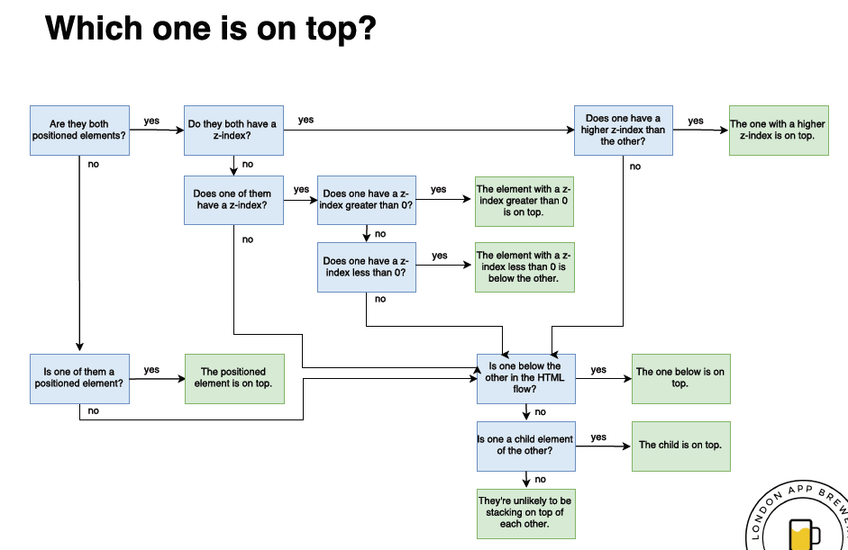**I did not like the explanation in the course. It got confusing. By default the zindex is 0. 1 makes it appear in front, -1 makes it appear further away from user.   
       Absolute positioning takes the element out of the order and relative to parent tag. It is not in flow of HTML content. It maintains the flow in relative positioning.
   12. [**Media Query Breakpoints**](https://www.w3schools.com/css/css_rwd_mediaqueries.asp) **Mobile first design. If else of HTML.**